INTERNATIONAL LOGISTICS AND TRADE APPLICATION AND RESEARCH CENTER
2024 UNIT ACTIVITY REPORT
I- GENERAL INFORMATION
A- Mission and Vision
Mission
To create new strategies parallel to developments in international trade and logistics by providing university-public-industry cooperation in international trade and logistics, to conduct scientific studies and produce projects in order to determine the potential that will provide innovation for the international trade and logistics sector and to ensure the competitiveness of the sector.
Vision
To ensure that small and medium-sized enterprises (SMEs) in Kahramanmaraş do foreign trade and increase their foreign trade volumes together with university-industry cooperation; to carry out research, training and project activities for SMEs and university students; to be one of the solution partners of stakeholders in the logistics and foreign trade sector.
Objectives
Objectives within the KSÜ International Logistics and Trade Application and Research Center
• Sharing information for small and medium-sized enterprises (SMEs) in Kahramanmaraş to open up to the international market and providing support for the training of relevant personnel to provide these companies with the ability to export and/or increase their foreign trade volumes.
• Conducting market field research with a scientific approach and developing new projects in order to increase the international trade market diversity of companies and to increase their share in existing markets and to ensure their competitiveness.
• Providing support for regional development and environmental sustainability by reducing carbon emissions with railway transportation by activating the Türkoğlu Logistics Center located in the region.
• Providing foreign trade certificate trainings that will enable KSÜ students and sector employees to increase their competencies.
• Observing and perceiving real business life practices in areas such as International Trade, Logistics and International Marketing and ensuring that a solution-oriented approach can be brought to current issues and problems using interactive participation training techniques.
• Ensuring that the real expectations of business life and current developments in doctrine can be followed through student-sector meetings and scientific events.
• Contributing to the increase in business performance of exporter and logistics service producer companies in Kahramanmaraş by improving the functioning of their business processes.
B- Authority, Duties and Responsibilities
To carry out activities related to international trade and logistics with a holistic approach and by taking stakeholders into consideration; with an understanding that includes relevant sectors and other stakeholders.
• To bring students and sector representatives together under the name of International Trade and Logistics Days.
• To regularly research domestic and international internship opportunities for students.
• To provide training on subjects that will increase the professional skills of students, graduates and sector employees by organizing seminars, courses and certificate programs.
• To cooperate with businesses operating in the field of international trade and logistics, to establish contacts with organizations requesting personnel.
• To carry out research, application, training, publication and project activities in the field of international trade and logistics and to benefit from domestic and foreign experts in the realization of these activities.
• To organize seminars, congresses, workshops or conferences at national and international levels in the fields of international trade and logistics, to participate in such meetings, to carry out joint projects between various sectors and non-governmental organizations and the University, to cooperate with national and international organizations.
• To prepare and participate in projects on international trade and logistics in order to benefit from national and international funds.
• To organize seminars, events and projects on clustering and related issues, and to conduct research on the development of international trade and increasing competitiveness.
• To take necessary initiatives for the participation of students, academic staff or the University in national or international competitions organized in the field of international trade and logistics.
• To contribute to increasing employment by organizing events that will ensure the establishment and development of new and successful small businesses in order to create global born businesses.• To conduct studies that will increase the interest of stakeholders and the relevant environment in the center's programs and services, organize events, create bulletins for students, graduates, institutions and organizations regarding the activities and make all kinds of visual and printed publications in line with the center's objectives.
• To establish a library, a document center, and a data bank introducing businesses in Kahramanmaraş and them in line with the center's objectives.• To carry out other activities determined by the Director and the Board of Directors.
C- Information on the Administration
1- Physical Structure
2- Organizational Structure
International Logistics and Trade Application and Research Center
Director: Assoc. Dr. Meltem KILIÇ
Deputy Director: Assoc. Prof. Dr. Zümrüt Hatice ŞEKKELİ and Dr. Lecturer Abdullah ÖZÇİL
Board Members: Lecturer Mehmet Ali ORHAN, Lecturer Ebru EVLİYA, Res. Asst. Fatma Büşra KURT, Res. Asst. Yağmur MATYAR TANIR
3- Information and Technological Resources
4- Human Resources
5- Services Provided:
To ensure university-public-industry cooperation in the field of international trade and logistics, to establish contact with organizations requesting personnel, to carry out research, education, publication and project activities in this field, to organize national and international congresses, seminars, workshops, conferences and panels, to organize clustering studies for the development of international trade and increasing the competitive day, to bring university students and sector representatives together.
6- Management and Internal Control System
D- Other Matters
İİ- PURPOSES and OBJECTIVES
A- Purposes and Objectives of the Administration
B- Basic Policies and Priorities
C- Other Issues
İİİ- INFORMATION AND EVALUATIONS REGARDING ACTIVITIES
A-Financial Information
The International Logistics and Trade Application and Research Center did not have any budget expenditure in 2024.
1- Budget Application Results
2- Explanations Regarding Basic Financial Tables
3- Financial Audit Results
4- Other MattersB-Performans Bilgileri
B-Performance Information
C-Activity and Project Information
1. With the appointment of Assoc. Prof. Dr. Meltem KILIÇ as the director of the International Logistics and Trade Application and Research Center on 11.03.2024, Assoc. Prof. Dr. Zümrüt Hatice ŞEKKELİ and Dr. Lecturer Abdullah ÖZÇİL started to work as assistant directors of the center. Then, the members of the center's management board were determined.
2. On 08.05.2024, task distributions were made regarding the activities to be carried out within the center. In addition, suggestions were made regarding the events and activities that could be carried out in the 2023-2024 Spring semester. It was decided to plan an event for university students.
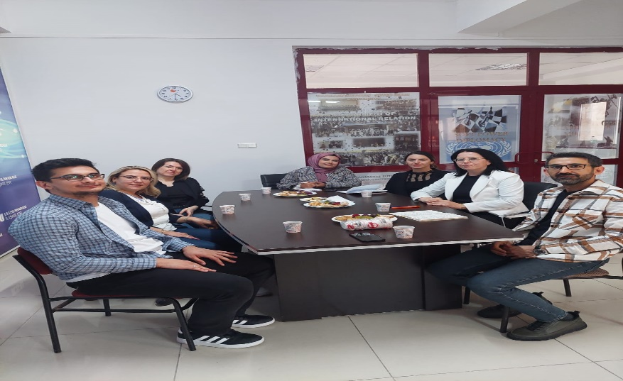

3. On 23.05.2024, an online interview was held via zoom with ERMA Group Project Manager Rabia Çolak on the subject of “A Green Transformation Carbon Footprint”. Within the scope of the interview, information was conveyed to the students on environmental pollution, what can be done to achieve sustainable development goals, carbon footprint and green logistics.
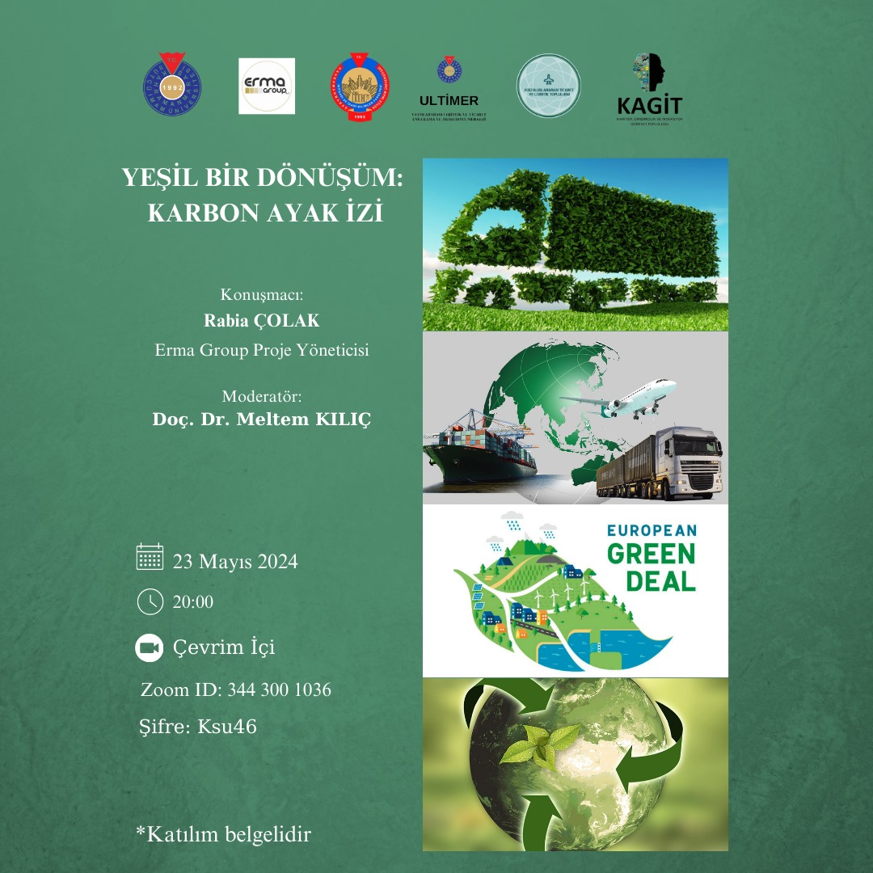
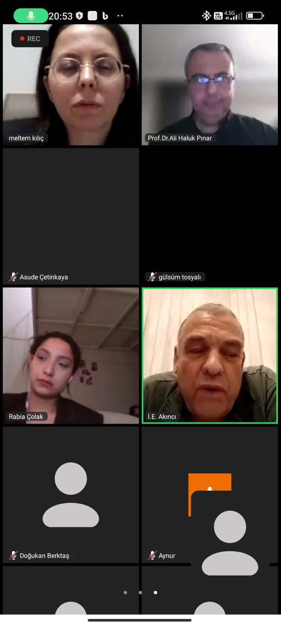
4. On 05.12.2024, Habitat Association Kahramanmaraş Provincial Representative Feyza Elif AKKAYA was hosted by the Kahramanmaraş Sütçü İmam University Radio within the scope of the December 5 World Volunteers Day program with the cooperation of Habitat Association, ULTİMER and SAM. Within the scope of the program, volunteering processes were mentioned in volunteering activities for students.
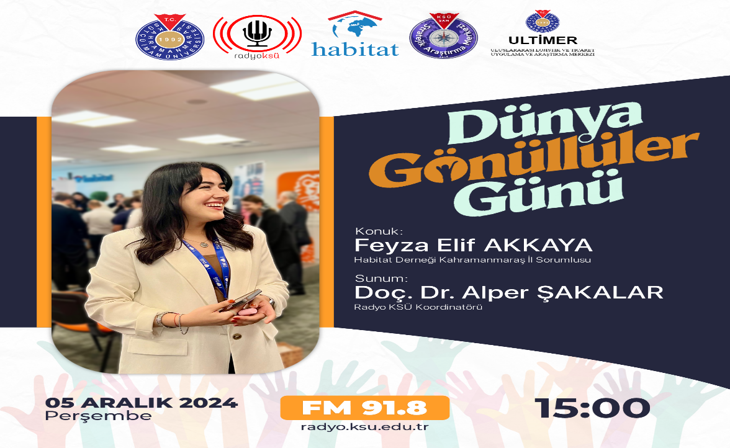

5. ULTIMER board of directors meeting was held on 06.12.2024. Within the scope of this meeting, the program titles that can be done in the field of international trade and logistics were determined. Collaborations that can be made with the Habitat Association and activity titles for students were prepared and presented to the Habitat Association. In addition, it was decided to create an infrastructure to provide training to improve the business English of students and sector employees.

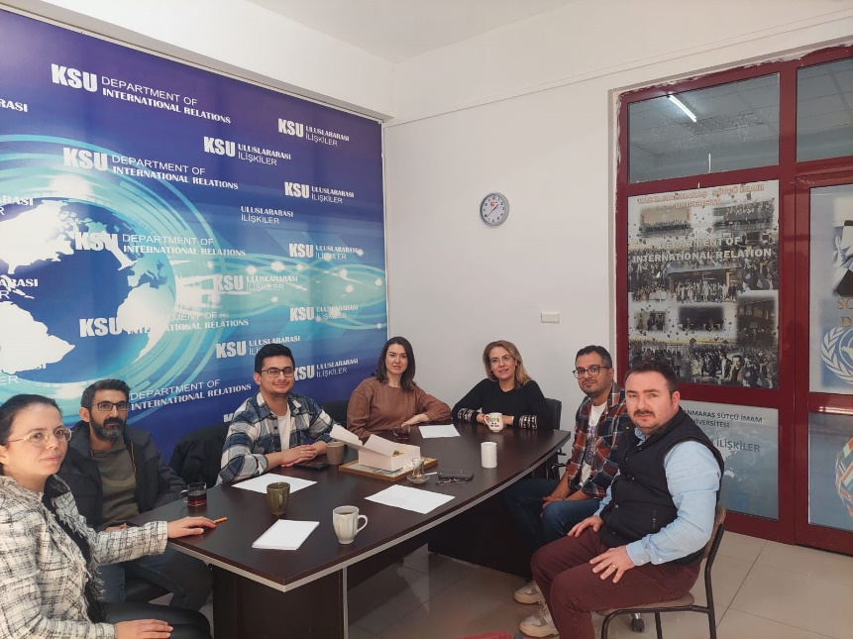

6. On 10.12.2024, an ULTIMER Workshop on "Humanitarian Aid Logistics Operation Processes" was organized for the students of the Faculty of Economics and Administrative Sciences, Department of International Trade and Logistics. The presentation of the program was made by Humanitarian Aid Logistics Expert Pınar KARAOĞLAN.

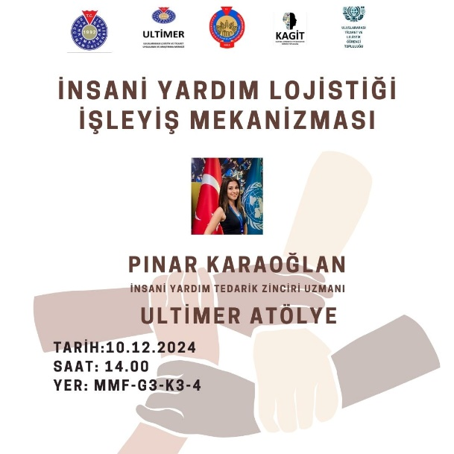

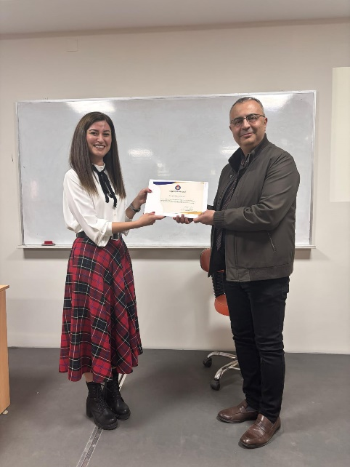

2. Performance Results Table
A- April-May-June Performance Results
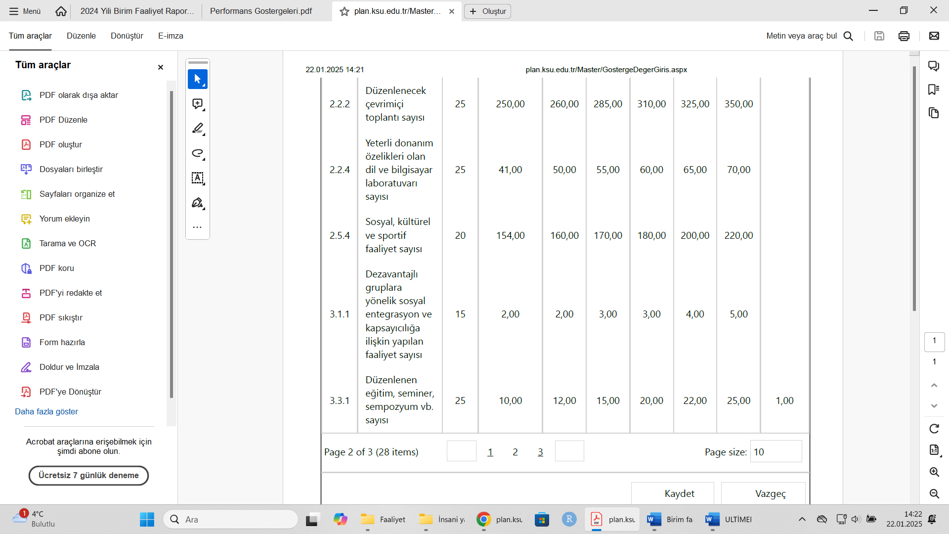

B-October-November-December Performance Results
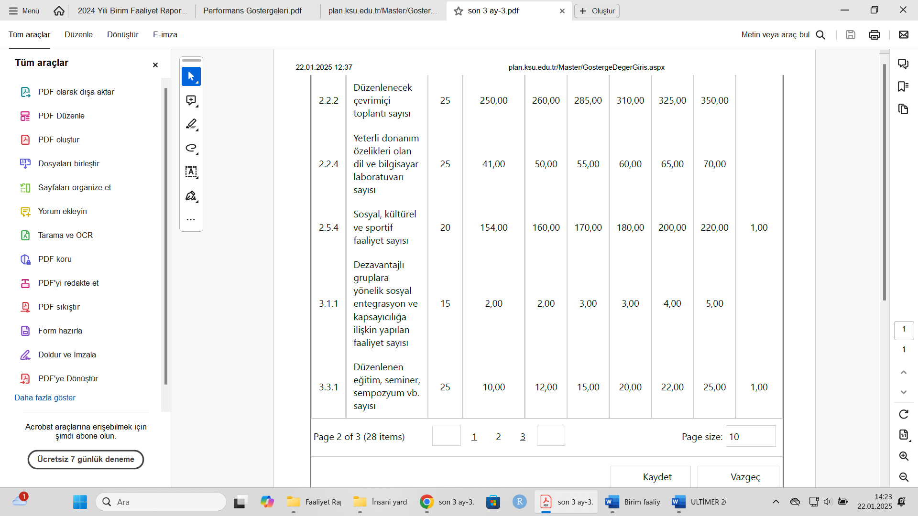
3. Evaluation of Performance Results
A- Satisfaction Survey of the interview titled “A Green Transformation: Carbon Footprint”
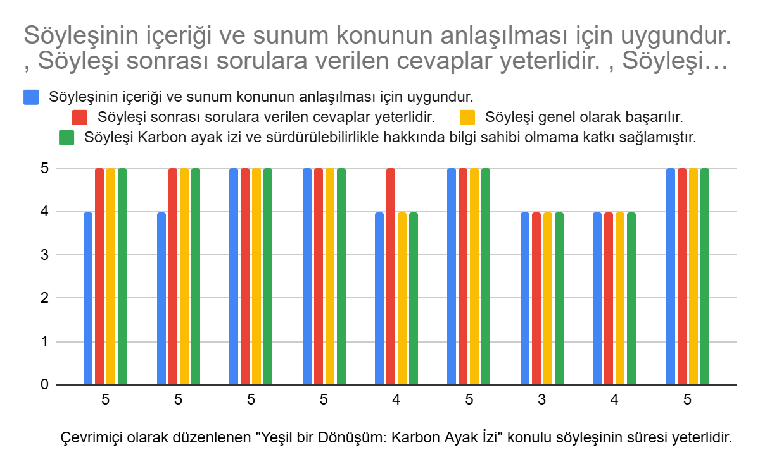

B “Humanitarian Aid Logistics Operation Processes” ULTIMER Workshop Satisfaction Survey
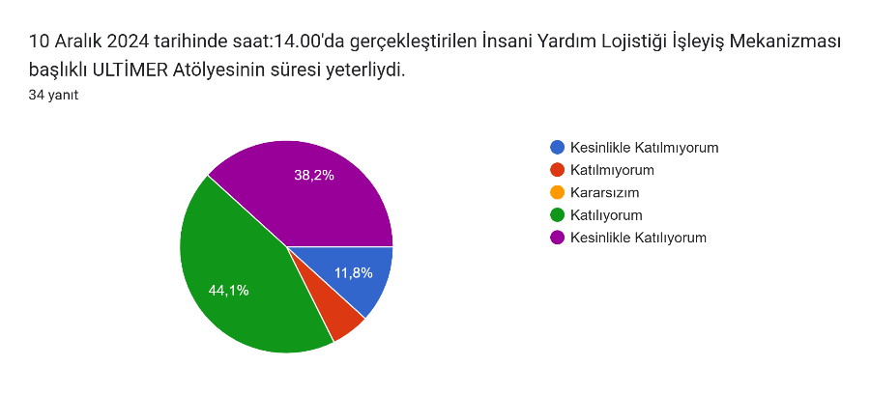
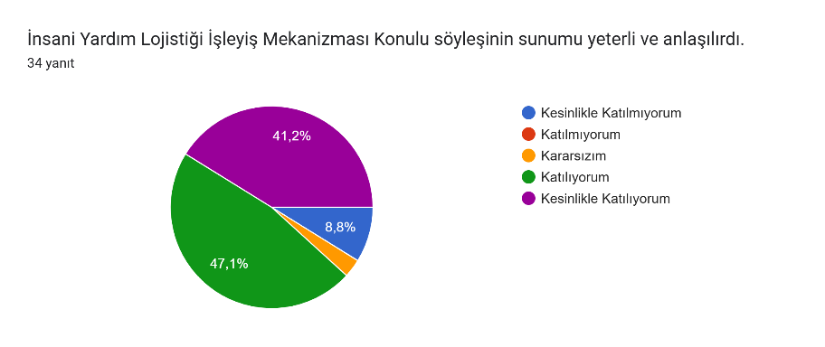
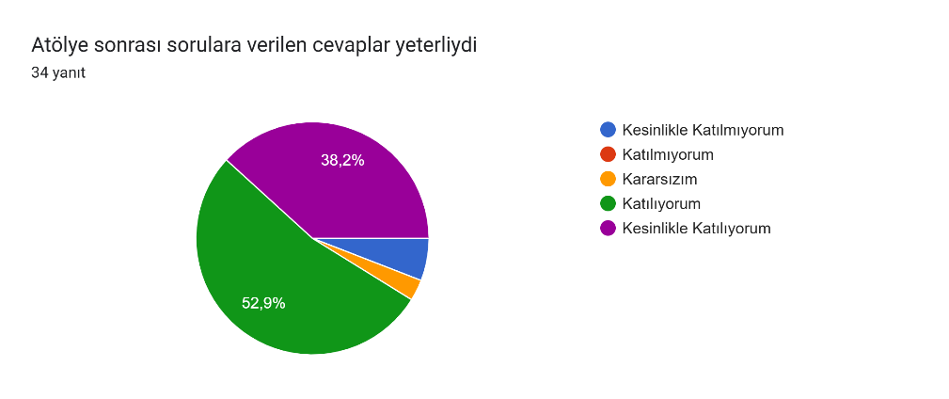
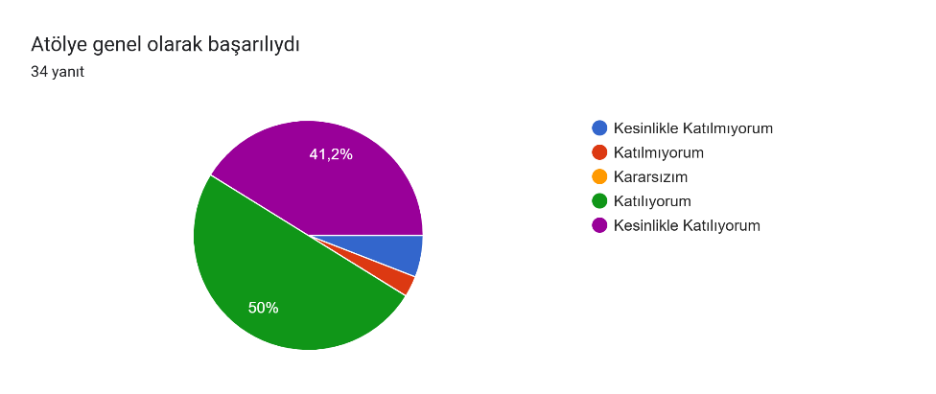
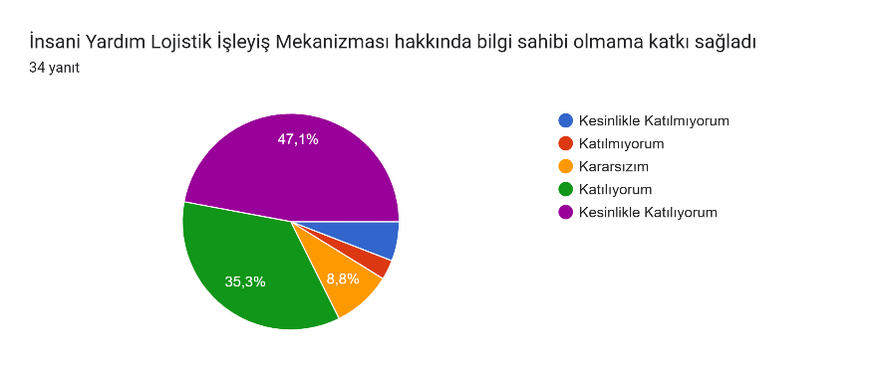

4- Evaluation of Performance Information System
5- Other Issues
IV- EVALUATION OF INSTITUTIONAL CAPABILITY AND CAPACITY
A- Advantages: A strong team, providing support for students' development in the field,
B- Weaknesses: Lack of university-industry cooperation, Carrying out project development activities
C- Evaluation
V- SUGGESTIONS AND MEASURES
• Joint studies should be carried out between research centers within our university and other universities.
• Studies on university-industry cooperation should be supported.
• Projects should be carried out in the field.

